StitChology Tote

tote Bag Pattern

Supplies:
1 yard Main Fabric
3/4 yard Lining Fabric
1 5/8 yards Light Weight Woven Fusible Interfacing
1 1/8 yards Mid Weight Fusible Interfacing
Thread to match

Remember This:
All seams include a ½ inch seam allowance, unless otherwise noted. We recommend you prewash and iron your fabric before cutting.

Cut This:
From Main Exterior Fabric cut:
2—17" X 18” wide rectangles for main body
1—7” X 10” rectangle for interior pocket
2—4” X 28” rectangles for handles
From Lining Fabric cut:
2—17" X 17 1/2"” wide rectangle for lining
1—7” X 10” rectangle for interior pocket
From Interfacing cut:
2—17” X 18” wide rectangles for main body (use the heavier interfacing)
2--17" 17 1/2" wide rectangles for lining body (use the lighter interfacing)
1—7” X 10” rectangle for interior pocket
2—4” X 28” rectangles for handles
Interfacing:
1. Following the interfacing manufacturer’s directions, fuse one strap interfacing to the wrong side of one fabric strap. Repeat for remaining strap.
2. Fuse one body interfacing to the wrong side of one body rectangle. Repeat for remaining body pieces.
3. Repeat for lining pieces.
4. Fuse the interior pocket interfacing to the wrong side of Main Fabric interior pocket piece.

Body and lining:
1. With right sides together, line up the two main body pieces. Pin and sew the two 18" sides and bottom using a ½ inch seam allowance. Press seams open.
2. Place Interior Pocket Pieces right sides together. Sew along all edges leaving a 3" opening along the bottom 10" edge. Clip corners and turn right side out through opening. Use turning tool to push out corners. Tuck in raw edges of opening and press.
3. Center pocket 4 1/2" down from one 17" lining edge. Pin in place.
4. Topstitch along pocket sides and bottom, starting and ending with a narrow triangle or satin stitch in each upper corner for reinforcement.
5. With chalk or marking pen, mark vertical line(s) on pocket as desired to divide pocket into sections. Sew on marked lines beginning at the bottom edge of pocket and remembering to backstitch at both beginning and end of each line.
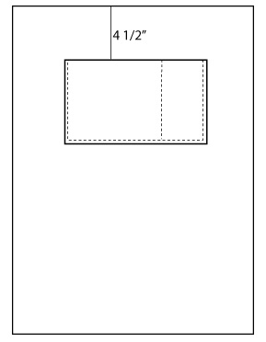
6. With right sides together, line up the lining pieces. Pin and sew the two 17 1/2" side seams and bottom, but leave about a 5 inch opening in the bottom. Press seams open.

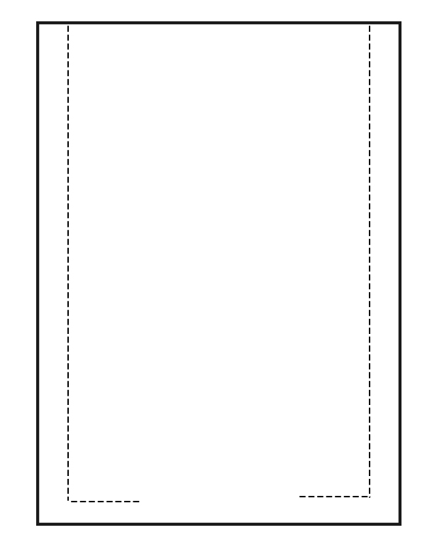

7. With right sides together, box the bottom corners of the bag by flattening the corners, bringing one bottom and one side seam together. Make sure the seams line up. Measure up 1 1/2" from the corner and make a mark perpendicular to the seam. This line should be 2" long. Sew along the marked line, then trim the excess corner fabric leaving a 1/4" seam. Repeat for remaining exterior corner and both lining corners.

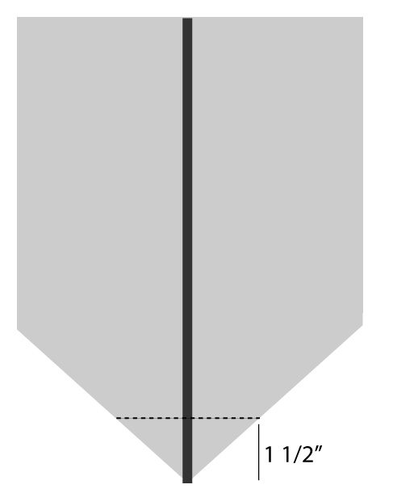

Handles:
1. With wrong sides together, fold each interfaced handle in half lengthwise and press.
2. Open this fold up. With wrong sides together, fold one long edge to the center crease and press again. Repeat for the other side so both long edges meet in the middle.
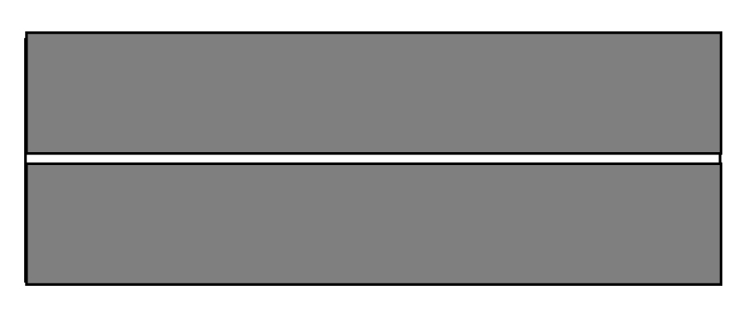

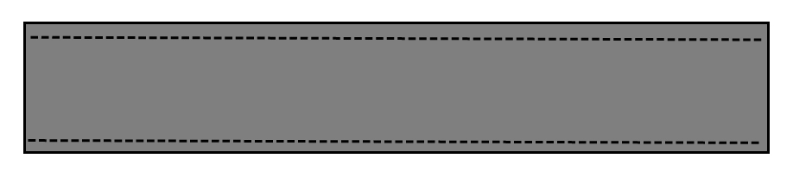
3. Fold in half again and press. The right side of the fabric should be exposed on all sides. Edge stitch along both long edges to secure all the layers in place. Repeat for second handle.

4. To determine where to put the handles, on the main body section measure over 3 inches from each side seam and mark with a pin. Repeat on the 2nd body piece.
5. Place a handle on the right side of the fabric with the outer edge of the handle lining up with the pin. Make sure you don’t have a twist in the handle, and that the handle is lying down on top of the bag. Baste in place. Repeat for second handle on back of bag.
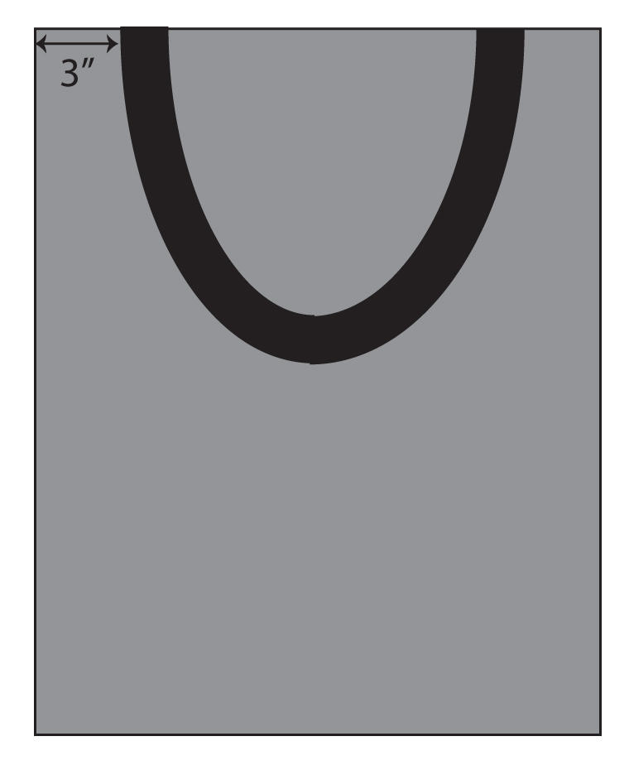

Attach the Layers:
1. Slide the bag into the lining so that right sides are together. Line up side seams and match up the top edges. Pin in place. The handles should be hanging in-between the bag and lining.

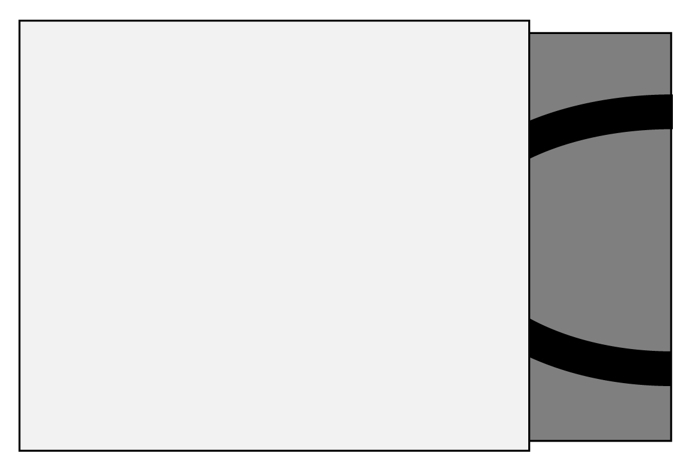

2. Sew around the top edge.
3. Pull the bag out through the opening in the lining, and turn the lining right side out.



4. Fold up the seam allowance on the lining opening and press in place. Edge stitch to close up the lining.
5. Turn the lining to the inside of the bag and press in place. If you like, top stitch around the top edge. You may also add a row of rickrack by placing the trim 1/4 inch below the top edge and stitching in place. Start and stop at a side seam, and when you finish, fold the top edge of the rickrack under 1/2 inch to clean up the raw edge.

Share:
Sling your new bag over your shoulder and share a picture of it with us on the Stitchology website page: https://www.facebook.com/pages/Stitchology or post it to Instagram with the tag #stitchologymade and don’t forget to LIKE us!

